# Project Report Titles

# Subscribers Galore: Exploring World’s Top YouTube Channels

* **INTRODUCTION:**

1.1Overview:

YouTube subscribe is a feature on the video-sharing platform YouTube that allows users to subscribe to channels and receive updates whenever new content is uploaded by the subscribed channels. When a user subscribes to a channel, they become a subscriber and their YouTube homepage and subscription feed will display the latest videos from the subscribed channels. Subscribing to a channel helps users stay connected with their favourite content creators and discover new content that aligns with their interests. Additionally, subscribing to a channel also enables users to engage with the creators through comments, likes, and shares.

* 1. Purpose:

The purpose of the YouTube subscribe feature is to allow users to stay connected with their favourite content creators and receive notifications whenever new content is uploaded. Subscribing to a channel ensures that users don't miss out on any updates and can easily access the latest videos. Additionally, subscribing allows users to engage with creators through comments, likes, and shares, fostering a sense of community and interaction within the YouTube platform.

**2. PROBLEM DEFINITION AND DESIGN THINKING:**

**2.1 .Empathy Map:**

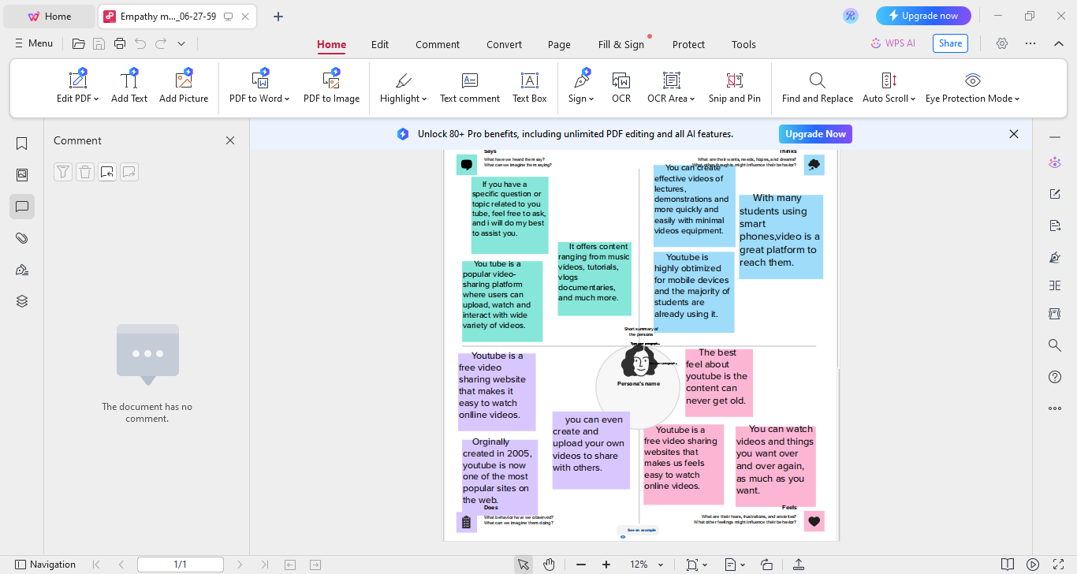

**2.2 Ideation & Brainstrorming Map:**

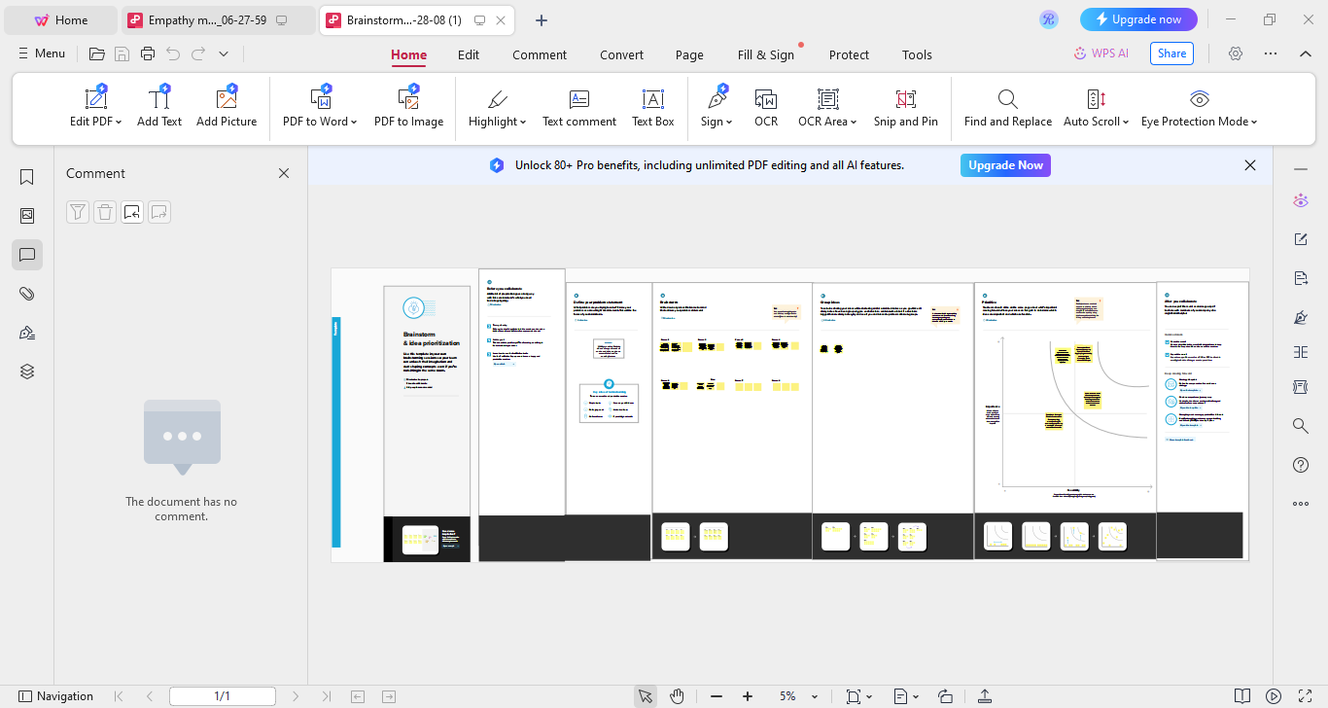

**3.** **RESULT:**

We created the data visualization such as dashboard and story using the dataset provided.

DASHBOARD:

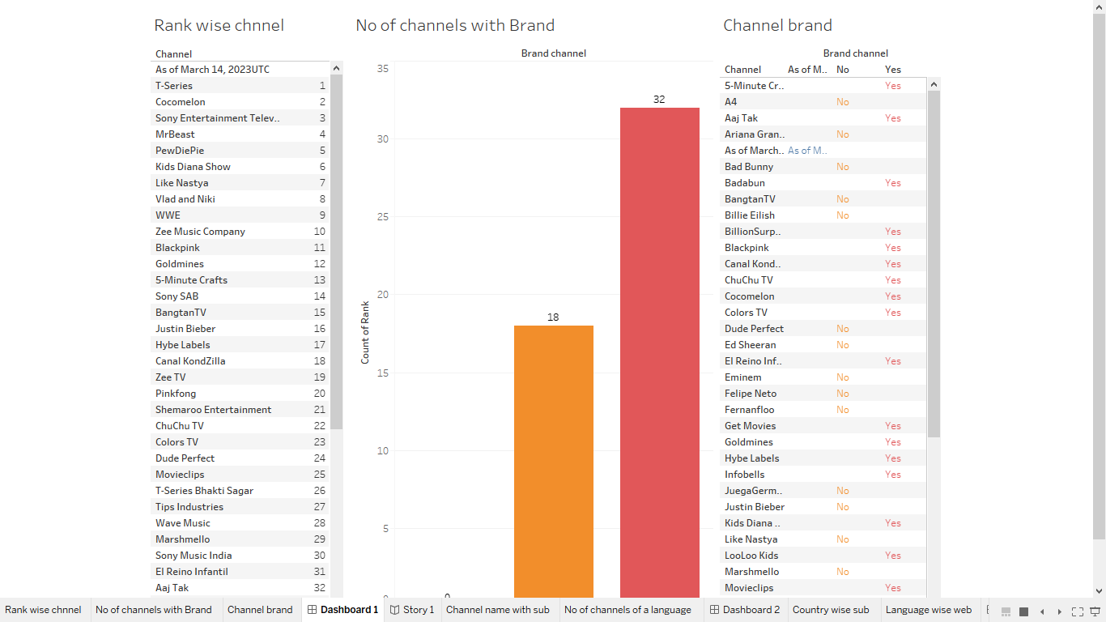

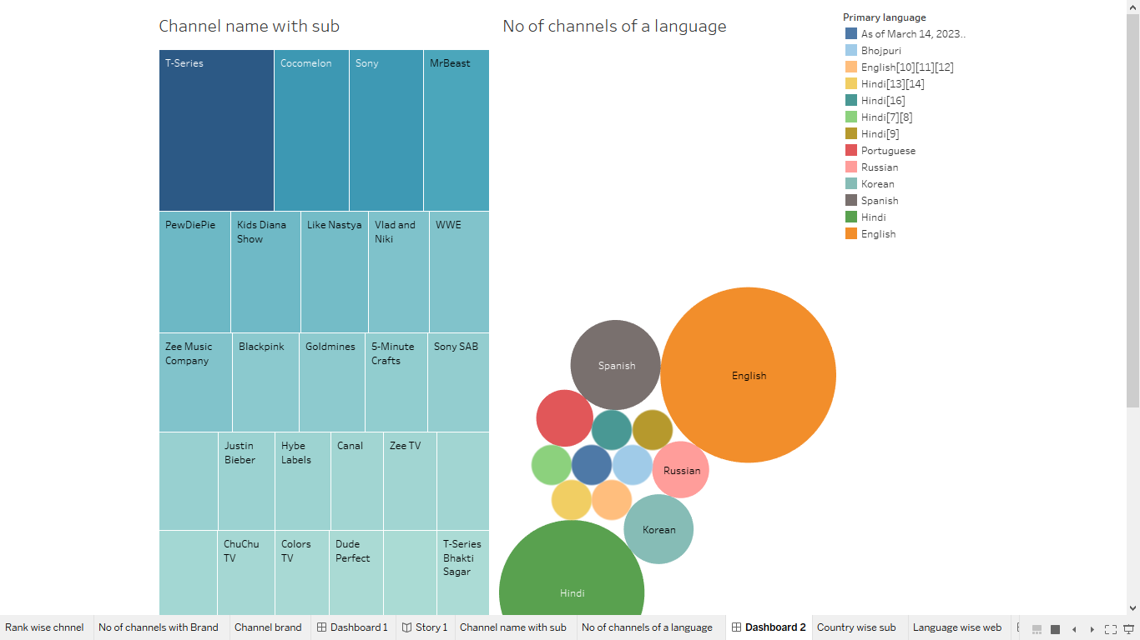

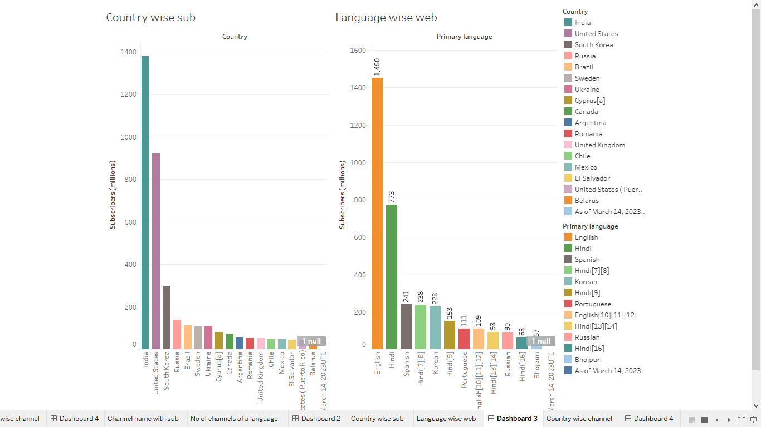

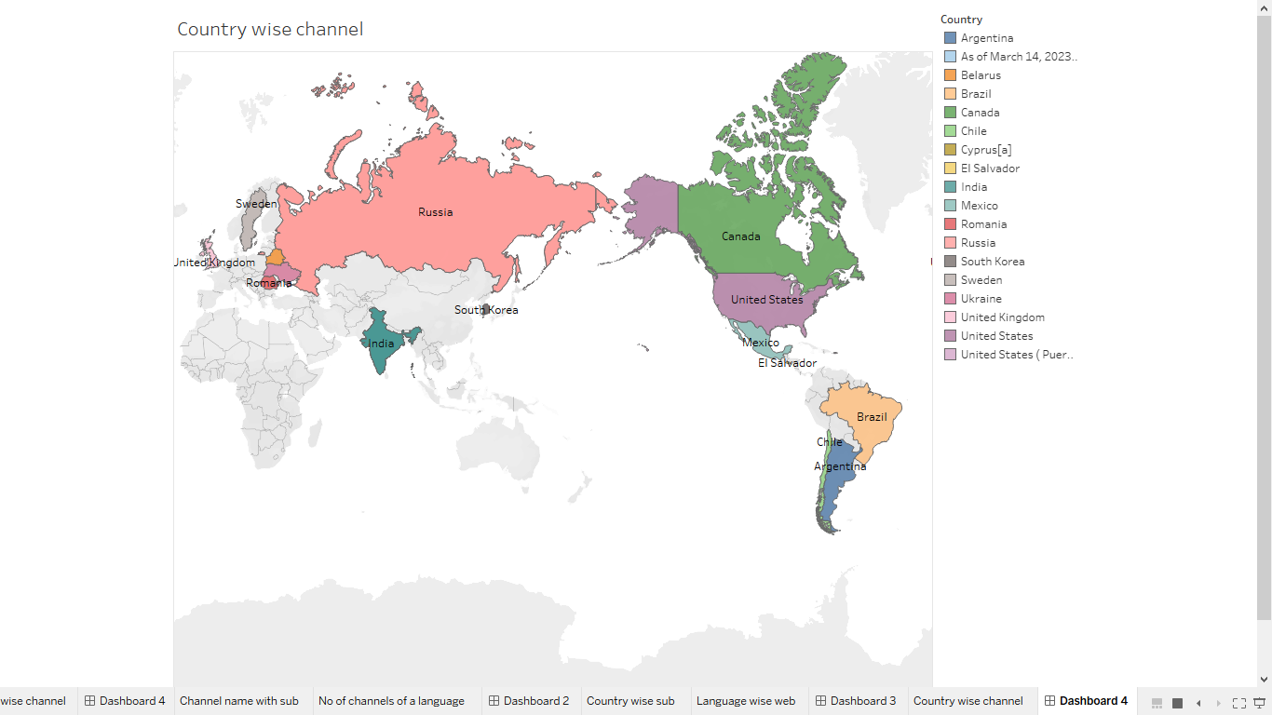

STORY:

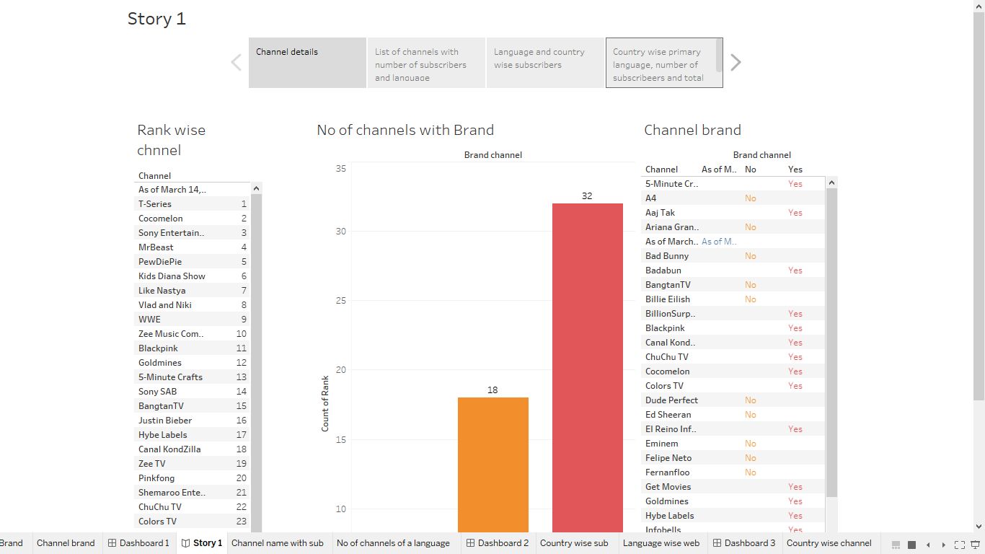

**4. ADVANTAGES & DISADVANTAGES**:

ADVANTAGES:

* One of the main advantages of the YouTube subscribe feature is that it allows users to stay updated with their favourite content creators. By subscribing to a channel, users can receive notifications whenever new videos are uploaded, ensuring that they never miss out on the latest content from their favourite channels.
* Additionally, subscribing to a channel helps support content creators. The more subscribers a channel has, the more likely it is to gain visibility and attract advertisers. By subscribing to a channel, users are showing their support for the creator and helping them grow their audience and potentially monetize their content.
* The subscribe feature also allows users to create personalized feeds. By subscribing to channels that align with their interests, users can curate their YouTube experience and have a constant stream of content that they enjoy.
* Furthermore, subscribing to a channel can foster a sense of community. Many content creators engage with their subscribers through comments, live chats, or exclusive content for subscribers. This creates a connection between the creator and their audience, allowing for a more interactive and engaging experience.
* Overall, the YouTube subscribe feature offers several advantages such as staying updated with favourite creators, supporting content creators, personalizing content feeds, and fostering a sense of community

DISADVANTAGES:

While the YouTube subscribe feature has many benefits, there are also some potential disadvantages:

Content overload: Subscribing to multiple channels can result in a flood of notifications and new content, which can be overwhelming for users who prefer a more curated viewing experience.

* Limited control over notifications: YouTube's notification system may not always be accurate or customizable, leading to users receiving notifications for content they are not interested in or missing out on important updates from their favourite creators.
* Privacy concerns: Subscribing to a channel means that the creator can see your username and potentially track your viewing habits. This may raise privacy concerns for some users who prefer to remain anonymous or keep their online activities private.
* Algorithmic recommendations: YouTube's recommendation algorithm heavily relies on subscribers and views to determine what content to promote. This can create a feedback loop where users are only exposed to popular channels and may miss out on discovering smaller or niche creators.
* Limited engagement: While subscribing allows users to engage with creators through comments and likes, the sheer number of subscribers on popular channels can make it challenging for creators to respond to every comment or engage in meaningful interactions with their audience.
* Potential for spam and clickbait: Some creators may use the subscribe feature as a way to gain more subscribers without delivering valuable content. This can lead to users being bombarded with spammy or clickbait videos, diminishing the overall user experience on the platform.

* It is important to note that these disadvantages may vary depending on individual preferences and usage patterns.

5.APPLICATIONS:

The YouTube subscribe feature can be applied in various ways. Here are a few examples:

* Personal use: Users can subscribe to channels that align with their interests, hobbies, or favourite topics. This allows them to stay updated with the latest videos and content from those channels, ensuring they never miss out on new releases.
* Education and learning: Many educational institutions, teachers, and experts have YouTube channels where they share valuable information and tutorials. By subscribing to these channels, students and learners can access educational content on a regular basis and enhance their knowledge in specific subjects.
* Entertainment and leisure: Users can subscribe to channels of their favourite musicians, comedians, vloggers, or other entertainers. This way, they can receive notifications whenever new music videos, comedy skits, or vlogs are uploaded, ensuring they always have fresh entertainment to enjoy.
* Business and marketing: Companies and brands often have YouTube channels where they share promotional videos, tutorials, product reviews, and other content related to their offerings. By subscribing to these channels, users can stay updated with the latest news and promotions from their favourite brands.
* Community engagement: Content creators often interact with their subscribers through comments, live chats, or exclusive content for subscribers. By subscribing to a channel, users can actively engage with the creator and other subscribers, fostering a sense of community and creating a platform for discussions and interactions.
* Overall, the YouTube subscribe feature can be applied in various contexts, catering to personal interests, education, entertainment, business, and community engagement.

**6. CONCLUSTION:**

In conclusion, the YouTube subscribe feature is a versatile tool that allows users to stay connected with their favourite channels and content creators. Whether it's for personal interests, educational purposes, entertainment, business promotions, or community engagement, subscribing to YouTube channels offers a convenient way to access and engage with a wide range of content. By utilizing this feature, users can ensure they never miss out on new releases, expand their knowledge, find entertainment, stay updated with their favourite brands, and actively participate in communities.

**7. FUTURE SCOPE:**

In the future, YouTube could potentially enhance the subscribe feature by incorporating more personalized recommendations based on user preferences and viewing history. This could help users discover new channels and content that align with their interests, further enhancing their overall YouTube experience.

Additionally, YouTube could also explore options for more interactive and immersive subscriber experiences. This could include features such as live chats during videos, exclusive content or perks for subscribers, and even virtual events or meetups with content creators.

Furthermore, YouTube could continue to improve the algorithm behind the subscribe feature to ensure that subscribers receive relevant and high-quality content. This could involve refining the recommendation system and addressing issues such as clickbait or misleading content, ultimately creating a more trustworthy and enjoyable platform for users.